Hackerrank question
Number Line Jumps | HackerRank
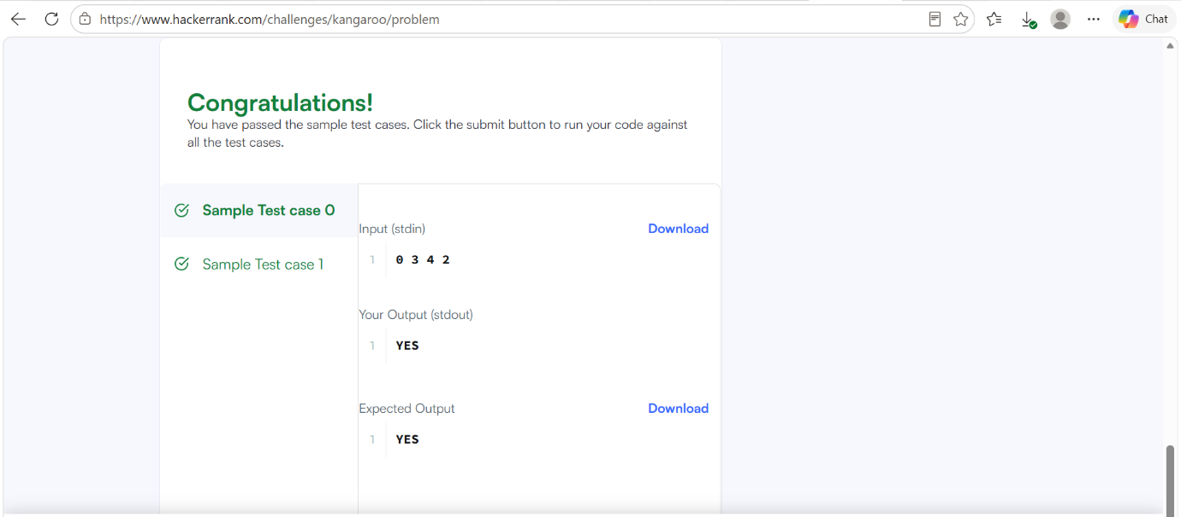

Code
#include <stdio.h>
#include <string.h>
const char* kangaroo(int x1, int v1, int x2, int v2) {
// If the first kangaroo is behind (x1 < x2), it must be faster (v1 > v2)
// If the first kangaroo is ahead (x1 > x2), it must be slower (v1 < v2)
if (v1 > v2 && (x2 - x1) % (v1 - v2) == 0) {
return "YES";
}
return "NO";
}
int main() {
int x1, v1, x2, v2;
if (scanf("%d %d %d %d", &x1, &v1, &x2, &v2) == 4) {
printf("%s\n", kangaroo(x1, v1, x2, v2));
}
return 0;
}

